NORTHWIND TRADERS

KPI’S

1. Total revenue

SELECT

SUM(od.unitprice * od.quantity * (1 - od.discount)) AS net_sales

FROM

order_details od

JOIN orders o ON od.orderid = o.orderid

JOIN customers c ON o.customerid = c.customerid

1. Total Quantity Ordered

SELECT

SUM(od.quantity) AS total_quantity_ordered

FROM

order_details od

JOIN orders o ON od.orderid = o.orderid

JOIN customers c ON o.customerid = c.customerid

1. Total products in catalog

SELECT COUNT(DISTINCT productname)

FROM products

1. Total customers

SELECT COUNT(DISTINCT productname)

FROM products

1. Total categories of products

SELECT categoryname

FROM categories

1. Total countries

SELECT COUNT(DISTINCT Country) AS numberofcountries

FROM customers

1. Number of orders by product category

WITH CategoryOrders AS (

SELECT

c.CategoryName,

COUNT(od.OrderID) AS NumberOfOrders

FROM

Order_Details od

JOIN

Products p ON od.ProductID = p.ProductID

JOIN

Categories c ON p.CategoryID = c.CategoryID

GROUP BY

c.CategoryName

)

SELECT

*,

(NumberOfOrders * 100.0 / (SELECT SUM(NumberOfOrders) FROM CategoryOrders)) AS Percentage

FROM

CategoryOrders;

1. Revenue by product category

SELECT categoryname, SUM(quantity*od.unitprice) AS revenue_by_category

FROM categories as c

JOIN products as p

ON c.categoryid=p.categoryid

JOIN order_details as od

ON od.productid=p.productid

GROUP BY categoryname

ORDER BY revenue_by_category DESC

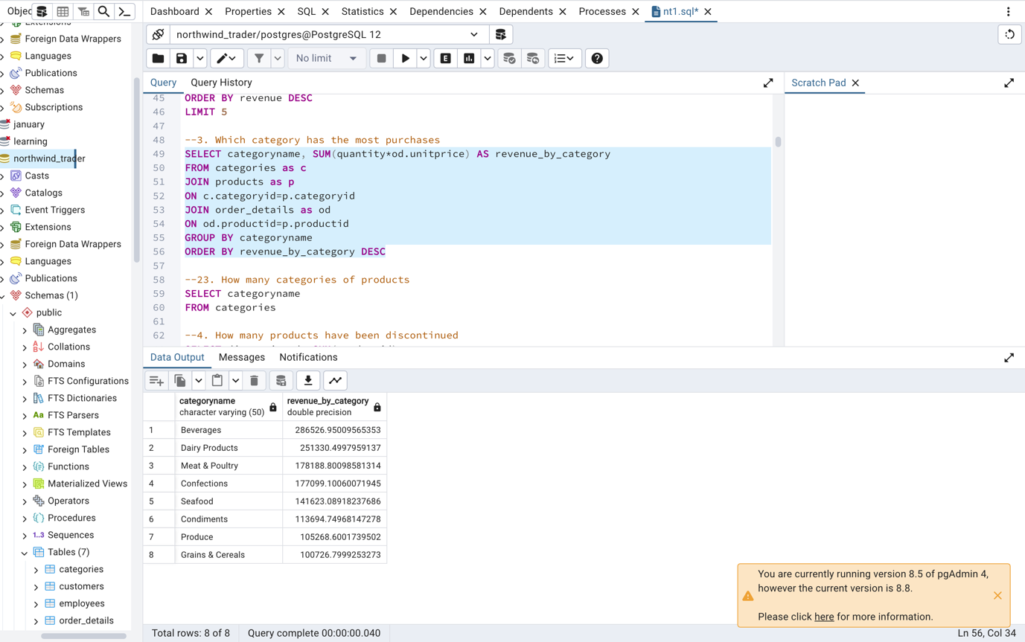

1. Top 10 product performance by revenue

SELECT

p.ProductName,

SUM(od.Quantity * od.UnitPrice * (1 - od.Discount)) AS Revenue

FROM

Order_Details od

JOIN

Products p ON od.ProductID = p.ProductID

GROUP BY

p.ProductID, p.ProductName

ORDER BY

Revenue DESC

LIMIT 10

1. Bottom 10 product performance by revenue

SELECT

p.ProductName,

SUM(od.Quantity * od.UnitPrice * (1 - od.Discount)) AS Revenue

FROM

Order_Details od

JOIN

Products p ON od.ProductID = p.ProductID

GROUP BY

p.ProductID, p.ProductName

ORDER BY

Revenue

LIMIT 10

1. Product performance by revenue

SELECT

p.ProductName,

SUM(od.Quantity * od.UnitPrice * (1 - od.Discount)) AS Revenue

FROM

Order_Details od

JOIN

Products p ON od.ProductID = p.ProductID

GROUP BY

p.ProductID, p.ProductName

ORDER BY

Revenue

1. Amount of order by company

SELECT

c.CompanyName,c.city,c.country,

COUNT(o.OrderID) AS NumberOfOrders,

SUM(od.Quantity * od.UnitPrice * (1 - od.Discount)) AS Revenue

FROM

Orders o

JOIN

Customers c ON o.CustomerID = c.CustomerID

JOIN

order_details od ON od.orderid=o.orderid

GROUP BY

c.CompanyName,city,country

ORDER BY

NumberOfOrders DESC;

1. Top 10 amount of order by company

SELECT

c.CompanyName,c.city,c.country,

COUNT(o.OrderID) AS NumberOfOrders,

SUM(od.Quantity * od.UnitPrice * (1 - od.Discount)) AS Revenue

FROM

Orders o

JOIN

Customers c ON o.CustomerID = c.CustomerID

JOIN

order_details od ON od.orderid=o.orderid

GROUP BY

c.CompanyName,city,country

ORDER BY

NumberOfOrders DESC

LIMIT 10

1. Bottom 10 amount of order by company

SELECT

c.CompanyName,c.city,c.country,

COUNT(o.OrderID) AS NumberOfOrders,

SUM(od.Quantity * od.UnitPrice * (1 - od.Discount)) AS Revenue

FROM

Orders o

JOIN

Customers c ON o.CustomerID = c.CustomerID

JOIN

order_details od ON od.orderid=o.orderid

GROUP BY

c.CompanyName,city,country

ORDER BY

NumberOfOrders

LIMIT 10

1. Number of customers by country

SELECT

Country,

COUNT(CustomerID) AS NumberOfCustomers

FROM

Customers

GROUP BY

Country

ORDER BY

NumberOfCustomers DESC

1. Total freight paid to the shippers

SELECT SUM(freight) AS total_freight, companyname

FROM orders AS o

JOIN shippers AS s

ON o.shipperid=s.shipperid

GROUP BY companyname

ORDER BY total_freight DESC

1. Total orders have been shipped and unshipped

SELECT

COUNT(CASE WHEN ShippedDate IS NOT NULL THEN OrderID END) AS ShippedOrders,

COUNT(CASE WHEN ShippedDate IS NULL THEN OrderID END) AS UnshippedOrders

FROM

orders;

1. Which shipping company was used the most?

SELECT SUM(orderid), companyname

FROM orders AS o

JOIN shippers AS s

ON o.shipperid=s.shipperid

GROUP BY companyname

ORDER BY SUM(orderid) DESC

